**Lab Goal :** The goal is to analyze a problem and involve branching and decision making in creating a solution for the problem. You must determine how many times to hop, when to turn, and most importantly, when to stop. You must create commands based on the various requirements of this problem.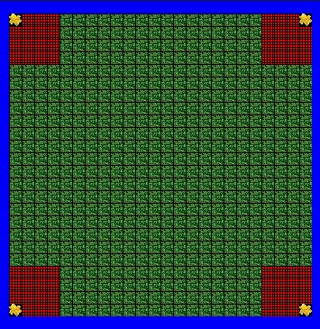

**Lab Description :** The goal is to program the Jeroo to hop around the perimeter of the island, and collect 4 flowers. Use if statements to help the Jeroo break through nets. Each cycle of the loop should produce movement on only 1 conditional at a time. If none of the various conditionals are met, the jeroo should hop in the direction it is currently facing. Failure to use the proper commands will mean your Jeroo is at risk as he may end up in the water or the nets while scouring the perimeter of the island searching for flowers.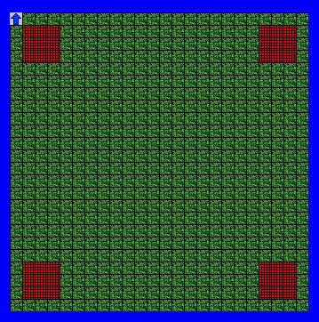

|  |
| --- |
| **Files Needed**  AdelleLabTemplate.jsc  AdelleLab.jev |

|  |
| --- |
| **Algorithm Help**  **Ending Screen :**  *Required Conditionals*  **Net Ahead – toss and hop**  **Flower Ahead - pick and hop**  **Water Ahead – turn right and hop**  **Clear Ahead - hop**  *Postcondition*  **Successful hop through the nets**  **Jeroo is not in the nets**  **Jeroo is facing north**  **Jeroo collects all 4 flowers** |

**Starting Screen : Ending Screen :**